EXPERIMENT 7

**Aim :** Making a 3D rocket using blender.

Follow the below steps -

1. Open Blender workspace and delete the existing cube, light and camera.
2. Click on the add option and add a cube.
3. Make subdivisions on this cube by going to the properties.
4. After making changes in the cube we will select the upper face of cylinder and then extrude it.
5. After the above step we will shape that extruded region like the upper part of the rocket using scale option. Similarly, we will create the fins of rocket.

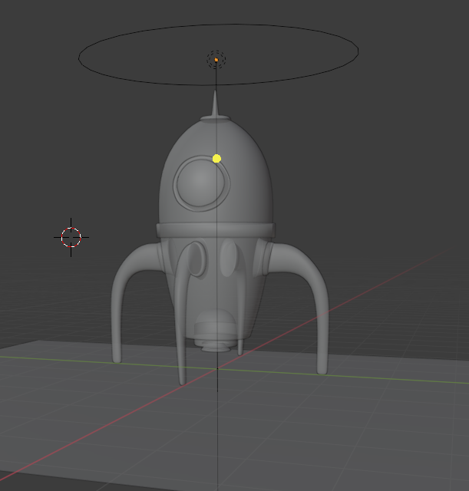

1. Now, color the rocket as per choice.
2. Go to add -> light. Place the light near the rocket and add color to it. I have added white light.
3. Make the background dark by going to universal properties.

OUTPUT –

